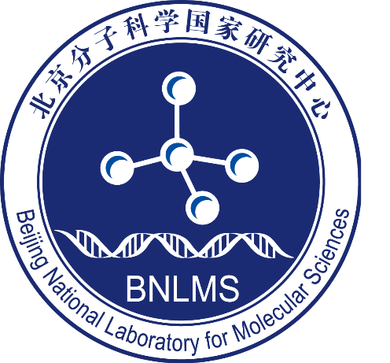

Application Form of

BMS-Junior Fellowship

（2024）

**Name：**

**Ph.D Granting Institution：**

**Major of Research：**

**Postdoctoral Supervisor’s Name：**

**Date** (yyyy/mm/dd)**：**

Beijing National Laboratory for Molecular Sciences

**1. Personal Information**

|  |  |  |  |  |  |  |  |  |  |  |  |  |  |  |  |  |  |  |
| --- | --- | --- | --- | --- | --- | --- | --- | --- | --- | --- | --- | --- | --- | --- | --- | --- | --- | --- |
| **1.1 Basic Information** | | | | | | | | | | | | | | | | | | |
| Name | |  | | Gender | | | | | |  | | Date of Birth(yyyy/mm/dd) | | | | |  |
| Marital Status | |  | | Identification Number | | | | | |  | | | | | | | |
| Phone Number | |  | | | | | | | | | | | | | | | | |
| Address | |  | | | | | E-mail | | | | | | | |  | | | |
| Postdoctoral  Supervisor’s  Name | |  | | | | | Estimated Time for Postdoctoral  Enrollment (yyyy/mm) | | | | | | | |  | | | |
| **1.2 Current Education/work Information** | | | | | | | | | | | | | | | | | | |
| □ **A.** Ph.D Candidate □ **B.** Ph.D graduated within three years prior to the call deadline | | | | | | | | | | | | | | | | | | |
| 1. Ph.D Candidate | | | Ph.D Granting Institution | | |  | | | | | | | | Ph.D Granting Country or Region | | |  | |
| Major of Research | | |  | | Doctoral Advisor’s Name | | |  | | | Estimated Time of Receiving Ph.D Degree (yyyy/mm) | | |  | |
| 1. Ph.D graduated within three years prior to the call deadline | | | Ph.D Granting Institution | | |  | | | | | | | | Ph.D Granting Country or Region | | |  | |
| Major of Research | | |  | | Doctoral Advisor’s Name | | |  | | | Time of Receiving Ph.D Degree (yyyy/mm) | | |  | |
| Current Host Institution | | |  | | | | | | | | | | | | |
| **1.3 Main Education/Research Experience**  （Education experience includes the experience from undergraduate student to the latest. Research experience includes visiting or training in research institutions, etc .） | | | | | | | | | | | | | | | | | | |
| Education Experience | Duration ( from yy/mm to yy/mm ) | | | | Institution | | | | Country or Region | | | | Major | | | Degree Granted | | |
|  | | | |  | | | |  | | | |  | | |  | | |
|  | | | |  | | | |  | | | |  | | |  | | |
|  | | | |  | | | |  | | | |  | | |  | | |
|  | | | |  | | | |  | | | |  | | |  | | |
| Research Experience | Duration ( from yy/mm to yy/mm ) | | | | Institution | | | | Country or Region | | | | Major | | | Titles of Research | | |
|  | | | |  | | | |  | | | |  | | |  | | |
|  | | | |  | | | |  | | | |  | | |  | | |
|  | | | |  | | | |  | | | |  | | |  | | |

**2. Academic Achievements**

|  |  |  |  |  |  |  |  |
| --- | --- | --- | --- | --- | --- | --- | --- |
| **2.1 Doctoral Dissertation: Title and Abstract (no more than 800 words)** | | | | | | | |
|  | | | | | | | |
| **2.3 Brief introduction of representative scientific research achievements (no more than 300 words)** | | | | | | | |
|  | | | | | | | |
| **2.2 Publications, Research Projects and Awards ( no more than 5 )** | | | | | | | |
| Academic Papers **(no more than 5 articles)** | Publication Date | Title | | Academic Journal | | | Ranking of Authors |
|  |  | |  | | |  |
|  |  | |  | | |  |
|  |  | |  | | |  |
|  |  | |  | | |  |
| Research Projects | Time(from yy/mm to yy/mm) | Title | Funding Institution | | Funds | | Contribution to the Project |
|  |  |  | |  | |  |
|  |  |  | |  | |  |
| Books | Publication Date(yy/mm) | Title | Publication Institution | | | | Ranking of Authors |
|  |  |  | | | |  |
|  |  |  | | | |  |
| Patents | Licensing Date (yy/mm) | Title | Type of Patent | | | Patent Number | Country or Region |
|  |  |  | | |  |  |
|  |  |  | | |  |  |
| Prizes/Awards | Granting Date（mm/yy） | Title | Institution | | | | Ranking of Awardees |
|  |  |  | | | |  |
|  |  |  | | | |  |

**3. Postdoctoral Research Project**

|  |  |
| --- | --- |
| 3.1 Title of Postdoctoral Research Project |  |
| 3.2Funding Area( choose one ) | □Green chemistry and technology ( N2,CO2; biomass; new paths for chemicals)  □Nano-functional materials and interfaces  □Organic optoelectronic materials and devices  □Advanced polymeric materials  □Molecular probe and chemical interventions in living biosystems  □Artificial intelligence chemistry  □Research on shortrange ordered non-crystal matter  □Key organic polymer in integrated circuit |
| 3.3 Abstract of Postdoctoral Research Project（no more than 300 words） |  |
| 3.4 Main Content of the Representative Academic Achievements（no more than 4000 words） |  |
| 3.5 Research Innovation（no more than 500 words） |  |
| 3.6 Promotional role of research programs in the subject areas（no more than 500 words） |  |

**4. Applicant’s Commitment**

|  |
| --- |
| I solemnly promise all the information that I submit above is true and is in accordance with academic morality. I undertake the responsibility that, in the event that BMS Junior Fellow is granted, the funds will be used for the purpose for which they have been granted, the project will be conducted as planned and the reports required by BNLMS will be submitted. All the research results produced under this project, whether in the form of research papers, publications or patents, etc., shall be marked “Beijing National Laboratory for Molecular Sciences (BNLMS)”.  Signature of the Applicant：  Date (yy/mm/dd): |

**5. Recommendation by Postdoctoral Supervisor**

|  |
| --- |
| Signature of the Postdoctoral Supervisor:  Date (yy/mm/dd): |

**6. Recommendation by Host Institution**

|  |
| --- |
| Signature of the Professor in Charge of Postdoctoral Affairs:  Date (yy/mm/dd): |

**7. Final Decision of BNLMS**

|  |
| --- |
| Signatures:  Date (yy/mm/dd): |

**Related certification materials**

**Please attach the representative scientific research achievements (This section is limited to no more than two papers, one book, one patent, or one award)**